Exercise 12 Output
Vanessa Belous
Nov 19th, 2025

(scroll down)
Screenshots: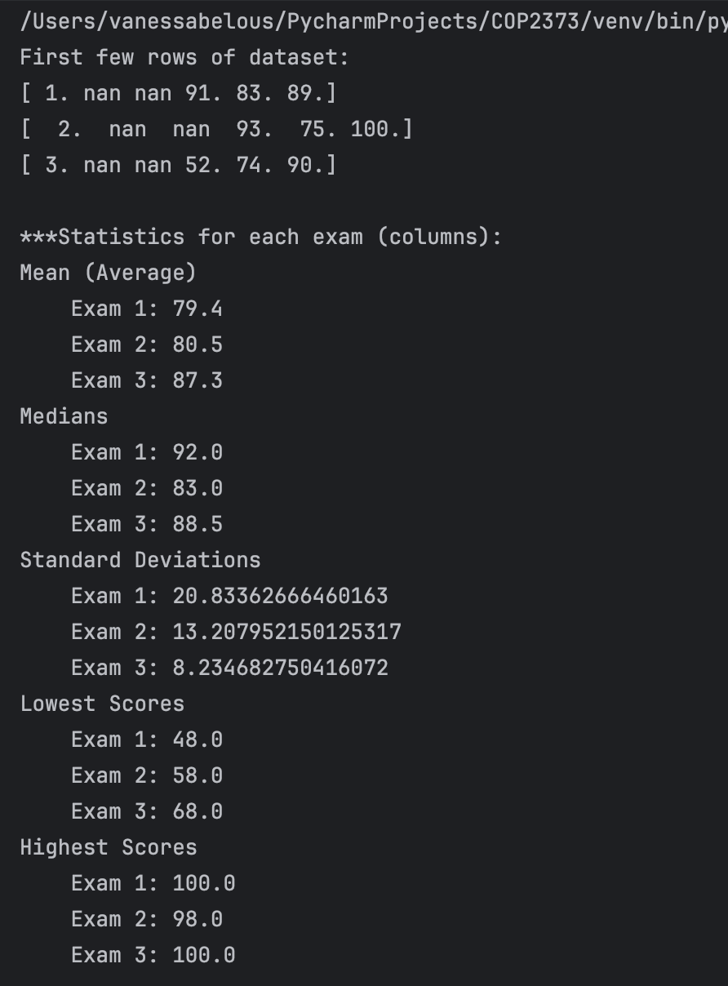
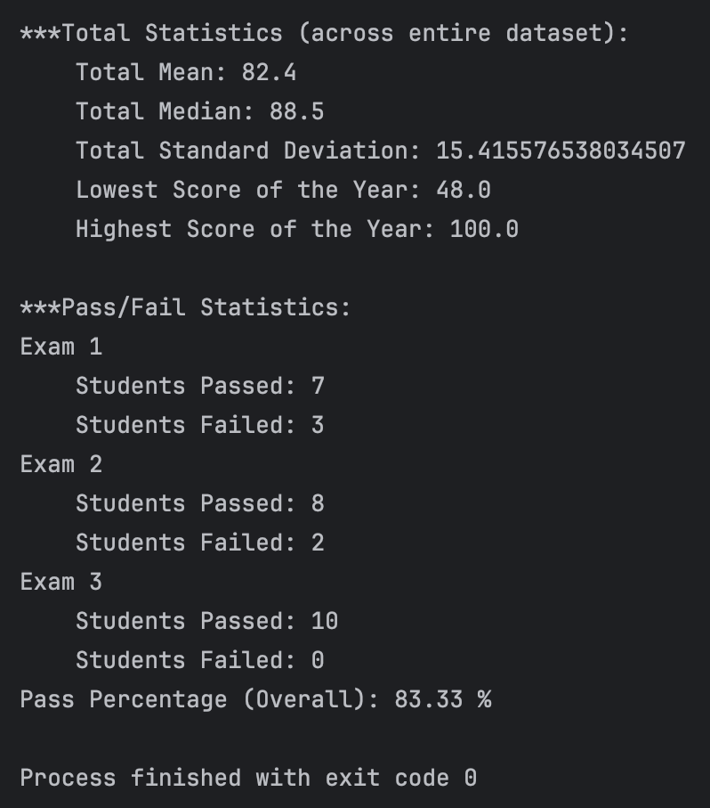

Repository Link: https://github.com/VBelous1/COP2373/tree/master/Week%2014

